Use Case Specification

DMT/RM01/TMP

|  |  |
| --- | --- |
| Project Code | PRJ_OnlineSurveyManagementSystem_001 |
| Project Name | Online Survey Management System |

|  |  |  |
| --- | --- | --- |
| Prepared/Modified by | Role | Date of Preparation |
| Team_5 | Analyst | 18th May, 2018 |
| Reviewed by | Role | Date of Review |
|  |  |  |
| Approved by | Role | Date of Approval |
|  |  |  |
| Circulation List |  | Version Number of the template:1.0 |
| Version Number | 1.0 |  |

<<Customer>> REVIEW HISTORY

<<Customer comments on the Use case along with the signed off is tracked here>>

|  |  |  |  |  |  |  |
| --- | --- | --- | --- | --- | --- | --- |
| Version | <<Version number>> |  |  |  |  |  |
| Date | <<Date of Review>> |  |  |  |  |  |
| Reviewed by | << Reviewer Name>> |  |  |  |  |  |
| Reviewed UI Specification doc | << Whether UI Specification doc is reviewed >> |  |  |  |  |  |
| All Open Queries/issues closed | << Whether all the open queries and issues resolved>> |  |  |  |  |  |
| Agreement on Assumptions | <<Whether all the assumptions have been agreed upon by the customer>> |  |  |  |  |  |
| Sign Off | <<Signature>> |  |  |  |  |  |

Disclaimer:

The scope of the project ‘University Admission System’ is restricted to the contents of this signed off use case.

TABLE OF CONTENTS

1. Use Case Name: Login to the Online Survey Management System 5

2. Actor(s): 5

3. Preconditions 5

4. Flow of Events 5

4.1 Basic Flow 5

4.2 Alternative Flows 6

4.2.1 Alternate Flow 1 6

4.2.2 Alternate Flow 2 6

4.2.3 Alternate Flow 3 7

Exception Flow 1: Exceeded Login Attempts 7

Exception Flow 2: Web Server Down 7

Exception Flow 3: Database Connectivity Error 7

Exception Flow 4: Network Connectivity Error 7

5. Post Conditions 7

6. Special Requirements 8

Performance 8

Availability 8

User Interface 9

Security 9

7. Extension Points 9

Extension in Alternate Flow 1: 9

Extension in Alternate Flow x: 9

8. Business Rules 9

9. Diagrams 10

Use Case Diagram for User 10

Activity Diagram 11

10. Scenarios 12

Success Scenarios 12

Failure Scenarios 12

11. Issues 12

12. UI Specifications 12

13. Inter System Dependencies 13

14. Integration with an already existing System of the <<Customer>><<Not Applicable>> 13

15. Assumptions 13

1. Use Case Name: apply for exam in bank exam portal

Use Case ID: SMS.SURVEYOR.FUNCTIONS_001

Brief Description:

This Use Case describes the process by which surveyor can login and create a questions to the Online Survey Management Webpage.For Login surveyor must be already registered on the System.

1. Actor(s):

1. Surveyor

1. Preconditions
2. Surveyor has already logged into the Online Survey Management Webpage.
3. Surveyor has entered the valid URL of Online Survey Management System and is directed to the home page of SMS
4. Surveyor has valid user id and the password
5. Surveyor has to create a survey questions
6. Flow of Events

4.1 Basic Flow

Name: Successfully logged into the Online Survey Management Webpage

1. Surveyor clicks on the Login link on the Online Survey Management System home page.
2. The system displays Login page
3. Surveyor enters Username
4. Surveyor enters Password
5. Surveyor clicks on the Login button
6. The system validates Username & Password
7. The system navigates Surveyor to the Online Survey Management web Page
8. Surveyor enters Survey title
9. Surveyor enter Survey description
10. Surveyor has to manage survey question
11. Surveyor has to create a questions and add a new question to the question database
12. Surveyor has to modify or delete the questions in the question database
13. Distribute existing survey to a list of existing respondent
14. Surveyor has to send an E-mail regarding survey
15. Surveyor has to send a remainder mail for non responding survey
16. View the list of pending survey
    1. Alternative Flows
       1. Alternate Flow 1(Surveyor clicks on online survey management webpage on google)
17. Surveyor clicks on the google to logged into the Online Survey Management System home page
18. The system displays Login page
19. Surveyor enters Username
20. Surveyor enters Password
21. Surveyor clicks on the Login button
22. The system validates Username & Password
23. The system navigates Surveyor to the Online Survey Management web Page
24. Surveyor enters Survey title
25. Surveyor enter Survey description
26. Surveyor has to manage survey question
27. Surveyor has to create a questions and add a new question to the question database
28. Surveyor has to modify or delete the questions in the question database
29. Distribute existing survey to a list of existing respondent
30. Surveyor has to send an E-mail regarding survey
31. Surveyor has to send a remainder mail for non responding survey
32. View the list of pending survey

4.2.2 Alternate Flow 2(SURVEYOR DIRECTLY LOGGED INTO THE WEBPAGE)

1. Surveyor directly clicks on the Online Survey Management web Page
2. Surveyor enters Survey title
3. Surveyor enter Survey description
4. Surveyor has to manage survey question
5. Surveyor has to create a questions and add a new question to the question database
6. Surveyor has to modify or delete the questions in the question database
7. Distribute existing survey to a list of existing respondent
8. Surveyor has to send an E-mail regarding survey
9. Surveyor has to send a remainder mail for non responding survey
10. View the list of pending survey

4.2.3 Alternate Flow 3

Exception Flow 1: Exceeded Login Attempts

1. Surveyor clicks on the Login link on the Online Survey Management System home page
2. The system displays Login page
3. Surveyor enters Username
4. Surveyor enters Password
5. Surveyor clicks on the Login button
6. The system validates Username & Password
7. The system validation fails due to invalid surveyor credentials and no more login attempts remaining
8. The system suspends the Surveyor account
9. The system informs the Surveyor that his/her account has been suspended

Exception Flow 2: Invalid survey title

1. Surveyor clicks on the Login link on the Online Survey Management System home page
2. The system displays Login page
3. Surveyor enters Username
4. Surveyor enters Password
5. Surveyor clicks on the Login button
6. The system validates Username & Password
7. The system navigates Surveyor to the Online Survey Management web Page
8. Surveyor enters Survey title
9. The system validation fails due to invalid surveyor title
10. The system returns to the Surveyor login page

Exception Flow 3: surveyor description should be blank

1. Surveyor clicks on the Login link on the Online Survey Management System home page
2. The system displays Login page
3. Surveyor enters Username
4. Surveyor enters Password
5. Surveyor clicks on the Login button
6. The system validates Username & Password
7. The system navigates Surveyor to the Online Survey Management web Page
8. Surveyor enters Survey title
9. Surveyor enter Survey description
10. The system validation fails due to invalid surveyor description

Exception Flow 4: invalid survey questions

1. Surveyor clicks on the Login link on the Online Survey Management System home page
2. The system displays Login page
3. Surveyor enters Username
4. Surveyor enters Password
5. Surveyor clicks on the Login button
6. The system validates Username & Password
7. The system navigates Surveyor to the Online Survey Management web Page
8. Surveyor enters Survey title
9. Surveyor enter Survey description
10. Surveyor has to manage survey question
11. The system validation fails due to invalid surveyor questionarries

Exception Flow 5: Web Server Down

1. Surveyor clicks on the Login link on the Online Survey Management System home page

Exception Flow 6: Database Connectivity Error

1. Surveyor clicks on the Login link on the Online Survey Management System home page.
2. The system displays Login page.
3. Surveyor enters Username
4. Surveyor enters Password
5. Surveyor clicks on the Login button
6. The system validates Username & Password

Exception Flow 4: Network Connectivity Error

1. Surveyor clicks on the Login link on the Online Survey Management System home page.
2. The system displays Login page.
3. Surveyor enters Username
4. Surveyor enters Password
5. Surveyor clicks on the Login button
6. The system validates Username & Password
7. Post Conditions

| Flow Name | Post Condition |
| --- | --- |
| Successfully Surveyor login to the Online Survey Management System | Surveyor will be logged in to the SMS successfully and system should navigate Surveyor to the Online Survey Management home Page |
| Login to the Online Survey Management system with reattempt | Surveyor will be logged in to the SMS successfully and system should navigate Surveyor to the Online Survey Management home Page |
| Directly logged into the Online Survey Management System page | Surveyor will be logged in to the SMS successfully and system should navigate surveyor to the Online Survey Management home Page |
| Exceeded Login Attempts | The system should suspend the surveyor account and should inform the Surveyor that his/her account has been suspended |
| Invalid survey title | The system should returns the surveyor home page and should inform the Surveyor that the survey title is invalid |
| Invalid Survey Description | The system should display an error message and should inform the Surveyor that the survey description should not be empty |
| Invalid survey questions | The system should display an error message to the Surveyor regarding Invalid survey questions |
| Web Server Down | The system should display an error message to the Surveyor regarding web server unavailability problem |
| Database Connectivity Error | The system should display an error message to the Surveyor regarding the database connectivity problem |
| Network Connectivity Error | The system should display an error message to the Surveyor regarding the network connectivity problem |

1. Special Requirements

Performance

1. Surveyor click on ‘login button’ it shall display the home page within 0.5 seconds of surveyor request

Availability

* 1. The Surveyor can access only on working days 24x7 but cannot working on national holidays.
  2. Application is up and running 24*7

User Interface

* 1. The letters on Menus shall be bold
  2. The active links shoul be displayed in red color
  3. The visisted links should be displayed in purpule color
  4. The Unvisited links should be displayed in blue
  5. The logout and back button should be available on every page of the application
  6. Look and feel and color of application should be proper.
  7. In case of Field level validation error messages should be displayed in red color.

Security

1. The system shall display the letters of passwords numbers in a masked format when they are entered by the Respondent.
2. After clicking on back on browser it should takes you back to the previous page in the list
3. After clicking on Forword on browser it should takes you forword to the next page in the list.
4. Surveyor Session should get expire if user is inactive for 10 mins.
5. Extension Points

Extension in Alternate Flow 1:

In step 6, if the respondent has entered wrong Surveyor credentials :

1. The system prompts the Surveyor to re-enter the credentials

2. Surveyor enters the username and password

3. The system takes user to the Step 3 of Basic Flow

Extension in Alternate Flow 2:

In step 8, if the respondent has entered wrong survey title in the box:

1. The system displays error message saying survey title is wrong.
2. It can either backs out of this use case, or retries after entering correct title.

Extension in Alternate Flow 3:

In step 9, if the respondent has entered wrong survey description in the box:

1. The system displays error message saying survey description is wrong.
2. It can either backs out of this use case, or retries after entering correct details.
3. Business Rules

| Business Rule Name | Business Rule Description | System action (if BR fails) |
| --- | --- | --- |
| BR01 | Surveyor must give valid credentials | Surveyor is prompted to re-enter the login credentials |
| BR02 | Same Surveyor cannot be registered again | Displays error message “You have already registered” |
| BR03 | Surveyor can view his application status only by entering valid URL Link | Displays error message “Invalid URL Link” |

1. Diagrams

Use Case Diagram for User

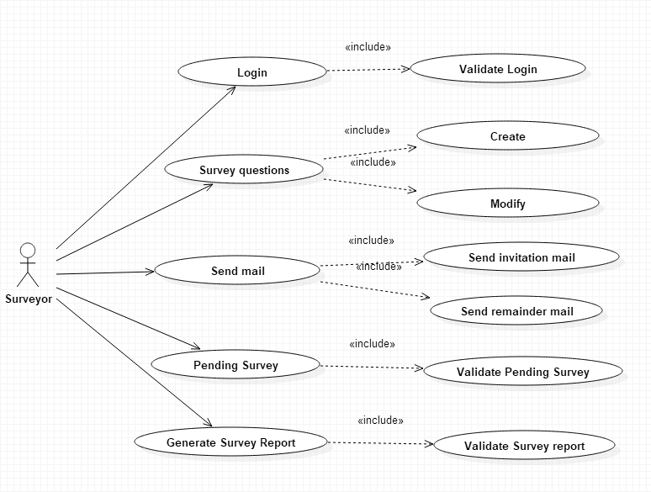

Activity Diagram<<Not Applicable>>

1. Scenarios

Success Scenarios

* Successful Surveyor login to the Online Survey Management System
* Login to the Online Survey Management System with reattempt
* Login to the Online Survey Management System directly

Failure Scenarios

* Exceeded Login Attempts
* Invalid Survey title
* Invalid Survey description
* Invalid Survey questions
* Web Server Down
* Database Connectivity Error
* Network Connectivity Error

1. Issues
2. What is the maximum size of username and password that a Surveyor can have?
3. What if the Surveyor is blocked after invalid login attempts for three times?
4. UI Specifications

https://surveywebpage.com

1. Inter System Dependencies

<<Mention the related functionality within the application that is impacted because of this use case. E.g. variable or value settings in this use-case which will have a direct impact on the functionality of another use-case. Or vice-versa.>>

Module:

Use case name:

Impact: If the user tries to apply for a course without login, he should be denied so. <<Mention the impact on the above mentioned Use case because of this use case>>

1. Integration with an already existing System of the <<Customer>><<Not Applicable>>

*<< This is especially applicable if the project at hand is an enhancement to an existing system.>>*

1. Assumptions
2. The Surveyor should be authenticate.
3. Surveyor should know the valid URL of Online Survey Management System.
4. Surveyor should have Google chrome browser for best view of site.

REVISION HISTORY OF THE WORK PRODUCT

<to be maintained by projects>

|  |  |  |  |  |  |
| --- | --- | --- | --- | --- | --- |
| # | Date | Version # | Section Changed | Details of changes made | Approved By |
| 1 |  |  |  |  |  |
| 2 |  |  |  |  |  |